1

TEACHER RESOURCES
TO BE PRINTED AS NEEDED

PARTICIPATION
Expectation/Activity:

 | Beginning | Approaching | Achieving | Exceeding

COMPLETION
Expectation/Activity:

 | Beginning | Approaching | Achieving | Exceeding

STORY REFLECTION

AVIATION NATION: AVIATOR STORY
Story read: Year: Location :
Who is the aviator featured in the story? Describe their background and contribution to aviation.

What were the key achievements or milestones in their career?

What impact did the aviator have on the aviation industry?

How is their work remembered or recognized today?

STORY REFLECTION

AVIATION NATION: INNOVATION STORY
Story read: Year: Location :
What is the main innovation discussed in the story? Describe the innovation and its purpose.

Who were the key figures involved in this innovation? Briefly describe their contribution.

Explain how this innovation was tested and implemented.

What long-term effects or legacy does this innovation have in today’s aviation industry?

AVIATION TIMELINE

INSTRUCTIONS AND RECOMMENDATIONS

Preparation:
- Print the provided timeline cards in colour to preserve their colour coding and visual appeal.
- Consider laminating the cards for durability and reusability. Laminating also protects the cards from wear and tear in the classroom environment.

Steps to create the timeline:
- Measure and cut strips of construction paper to create a horizontal timeline on the wall of your classroom.
- Label the timeline with appropriate time intervals or dates relevant to the unit or topic being studied. Use markers or labels for clear visibility.
- Use adhesive putty or tape to attach the timeline strips securely to the wall, ensuring they are straight and evenly spaced.

Adding timeline cards:
As you progress through the lessons and cover different events or milestones related to the unit, have students add the corresponding timeline cards to the timeline on the wall.

Student involvement:
Encourage students to create their own timeline cards for significant events or concepts they learn during the unit. These can be added to the timeline alongside the provided cards.

Reflecting on the unit’s progress:
By the end of the unit, the timeline on the wall will serve as a visual artifact representing the key events, concepts and learning milestones achieved throughout the unit.

Engage in discussions:
Use the completed timeline as a reference point for discussions, reflections, and review sessions. Encourage students to explain the significance of each event or concept as theyinteract with the timeline.

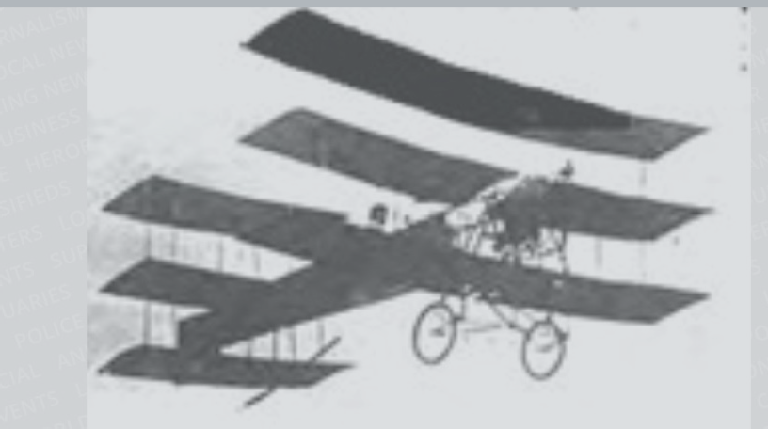

INNOVATION

1858
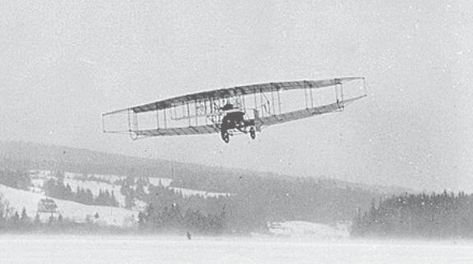
EVENT

1909
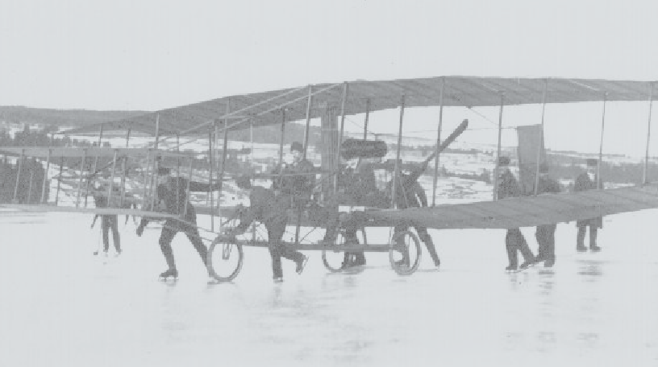

INNOVATION

1909
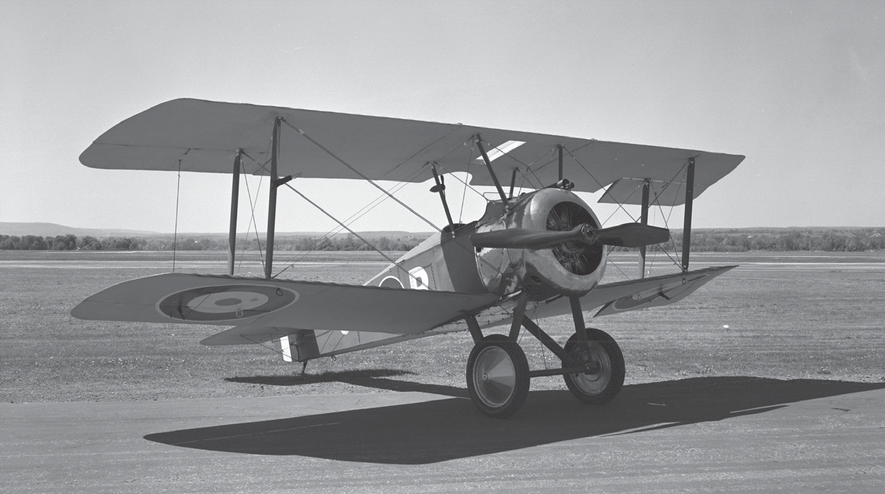
EVENT

1914

Avro Arrow

Aviation in Canada

Silver Dart

First World War

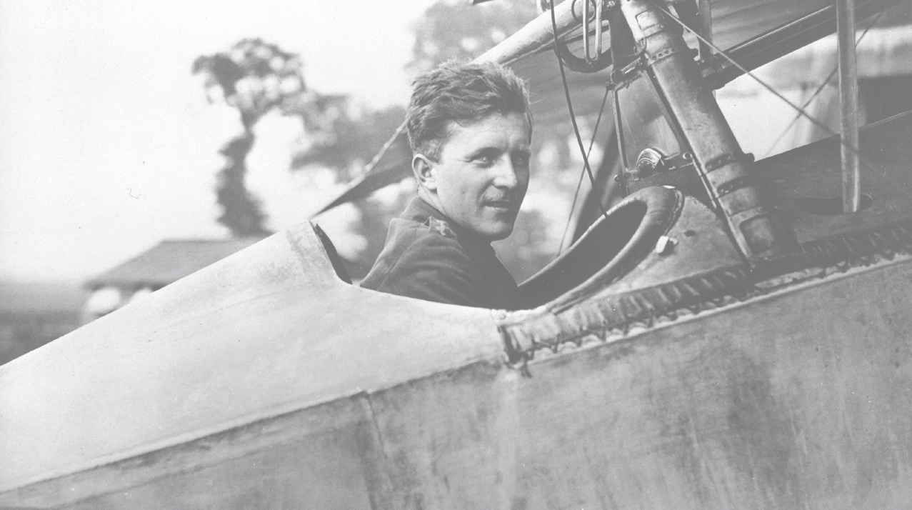
PEOPLE

1915
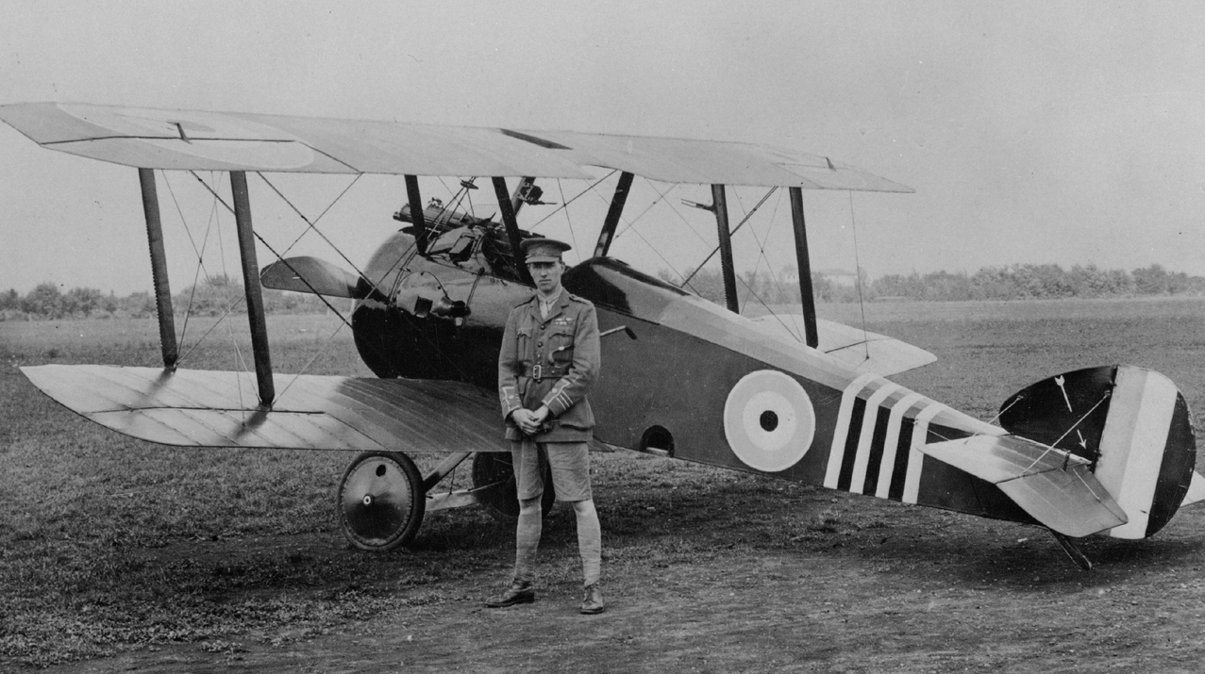
PEOPLE

1919
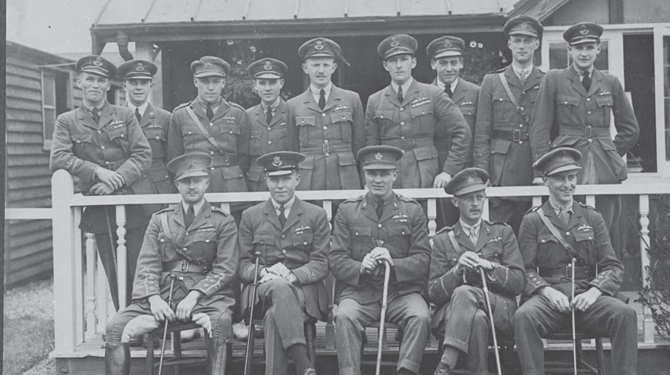
PEOPLE

1920
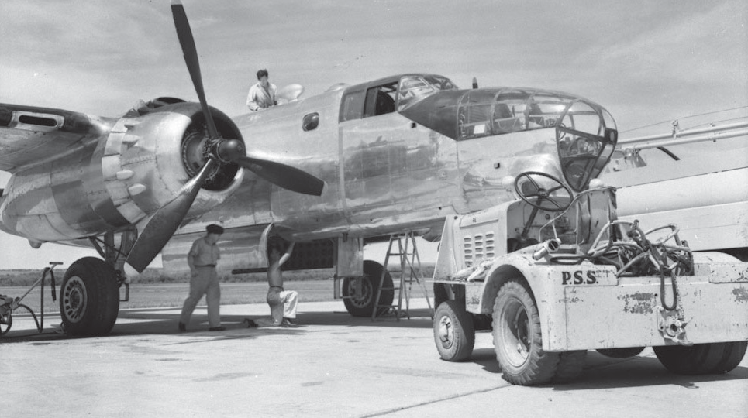
INNOVATION

1921

Billy Bishop

William “Billy” Barker

Canadian Air Force

First Photo Flight

PEOPLE

1924

Royal Canadian Air Force

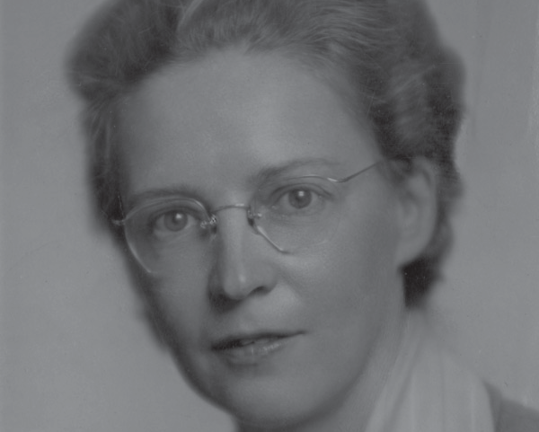
PEOPLE
1929

Elsie MacGill

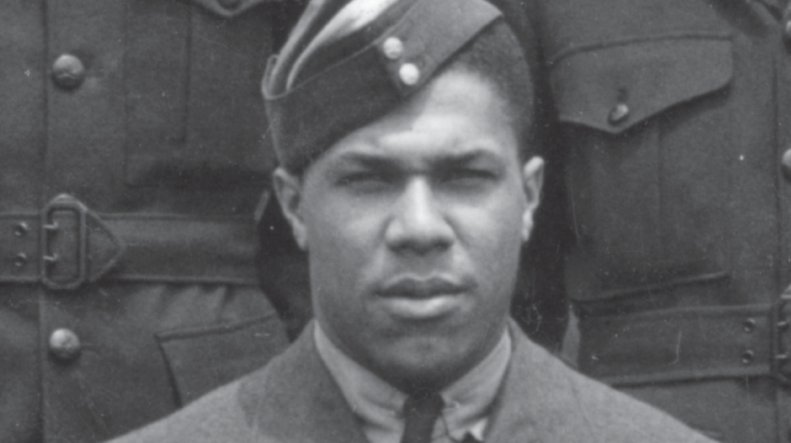
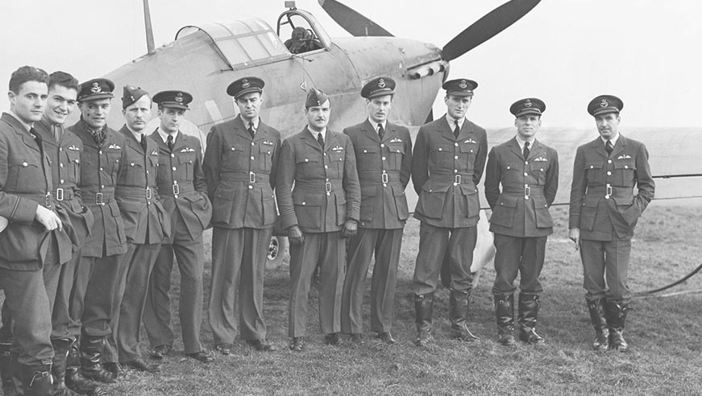
PEOPLE

1939
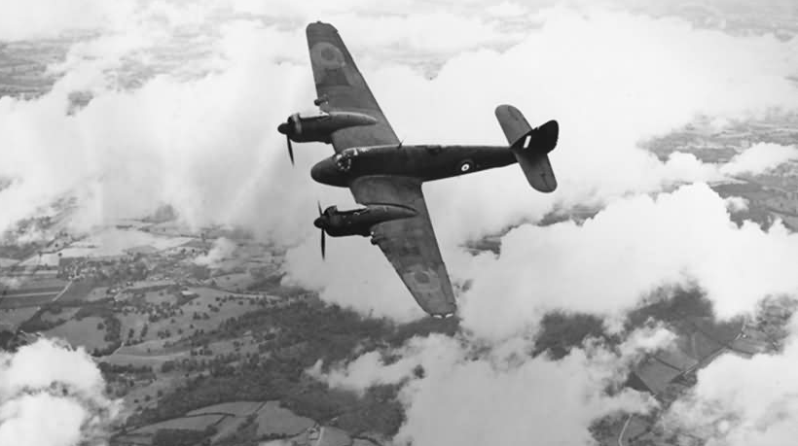
EVENT

1939

Allan Bundy

Second World War

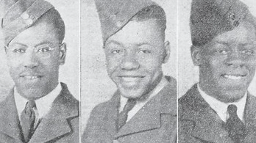
PEOPLE

1939-45
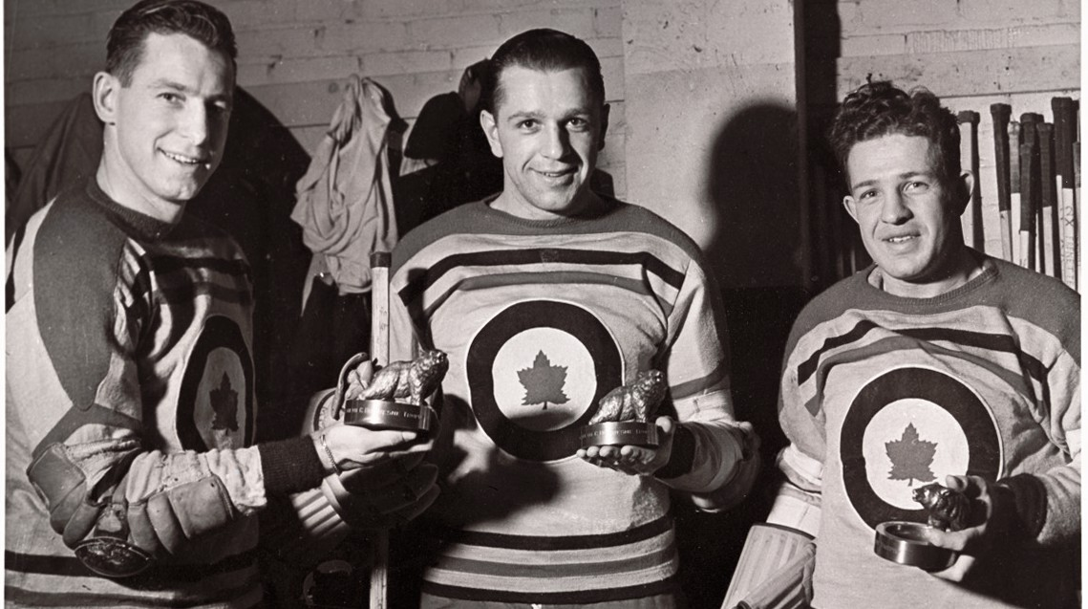
PEOPLE

1939-46
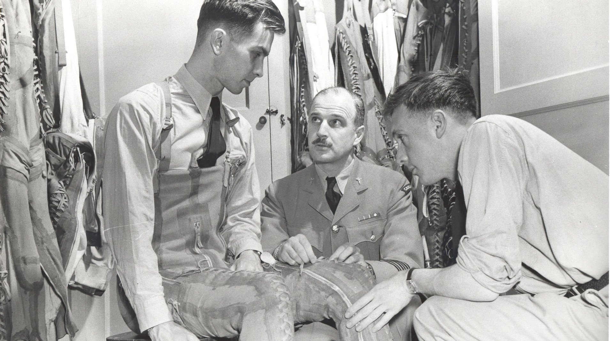
INNOVATION

1941
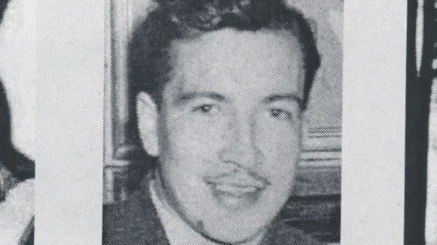
PEOPLE

1941

Carty Brothers

The Kraut Line

The G-Suit

Willard John Bolduc

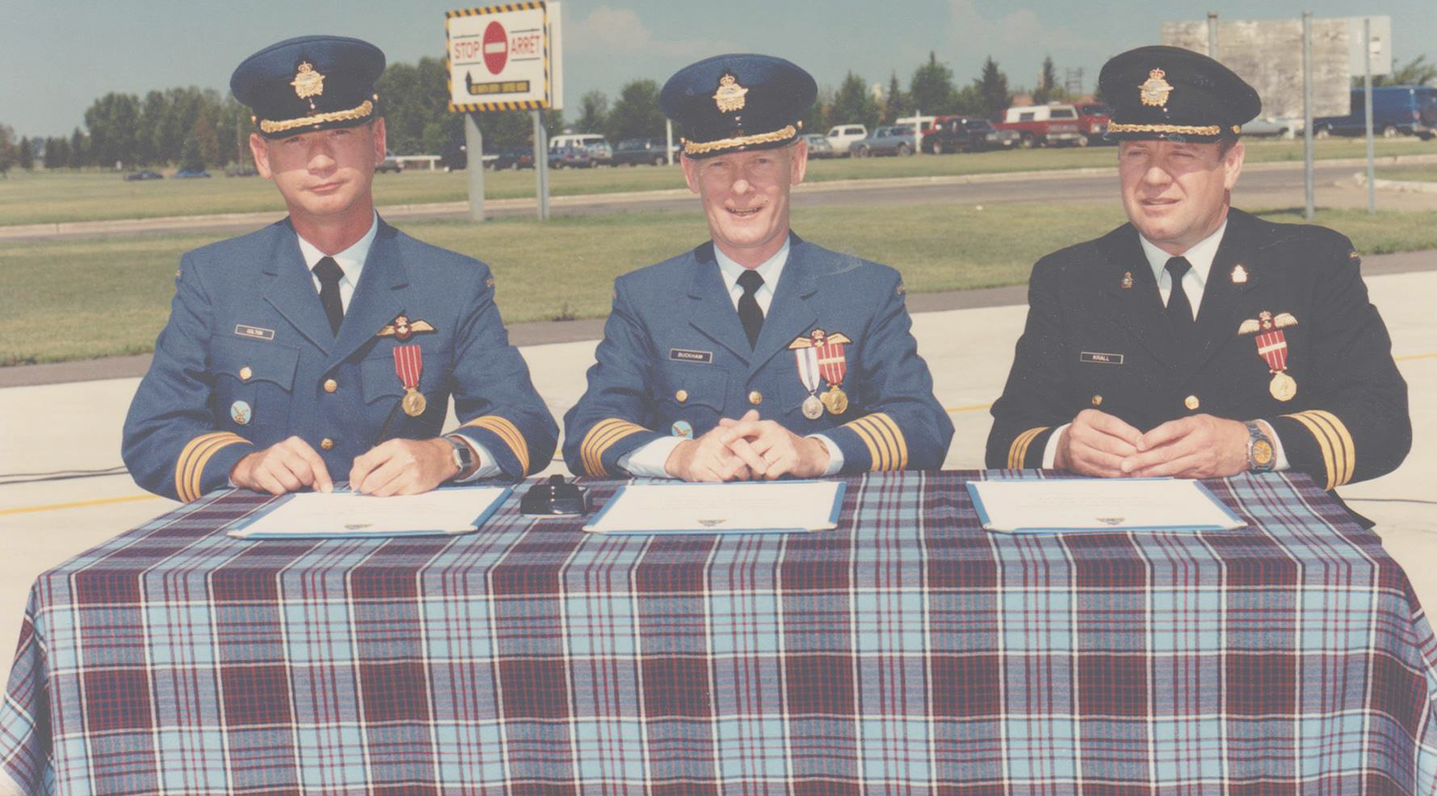
EVENT

1915
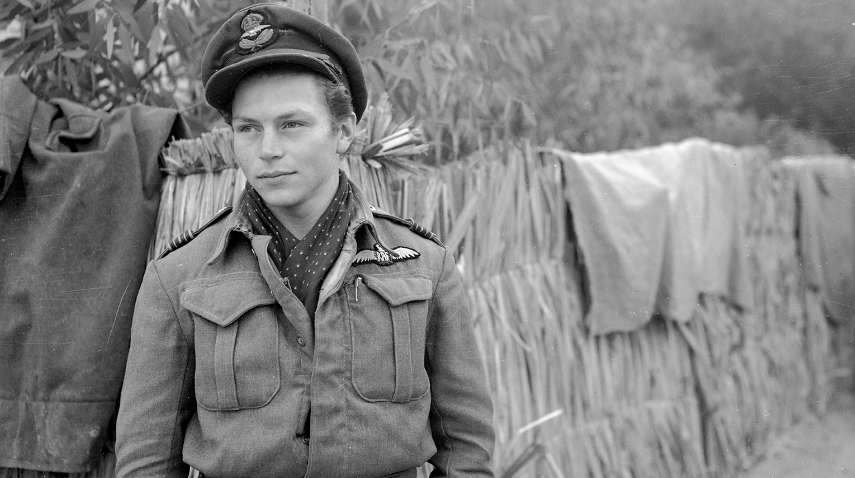
PEOPLE

1944
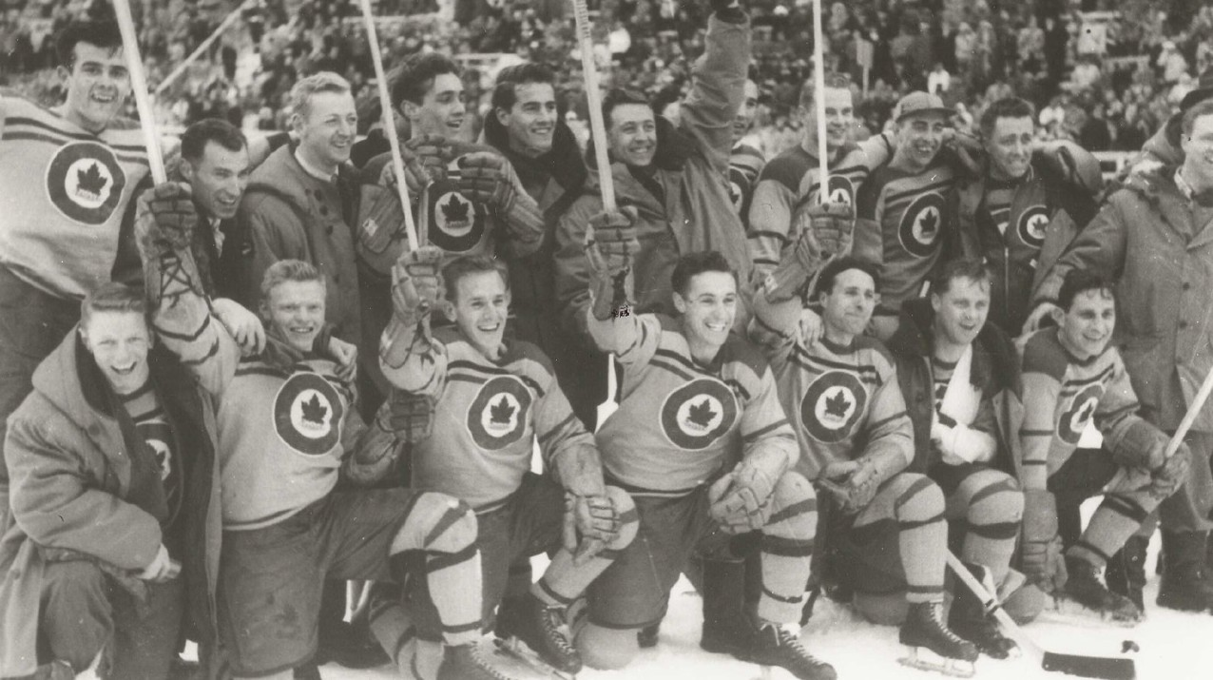
PEOPLE

1948
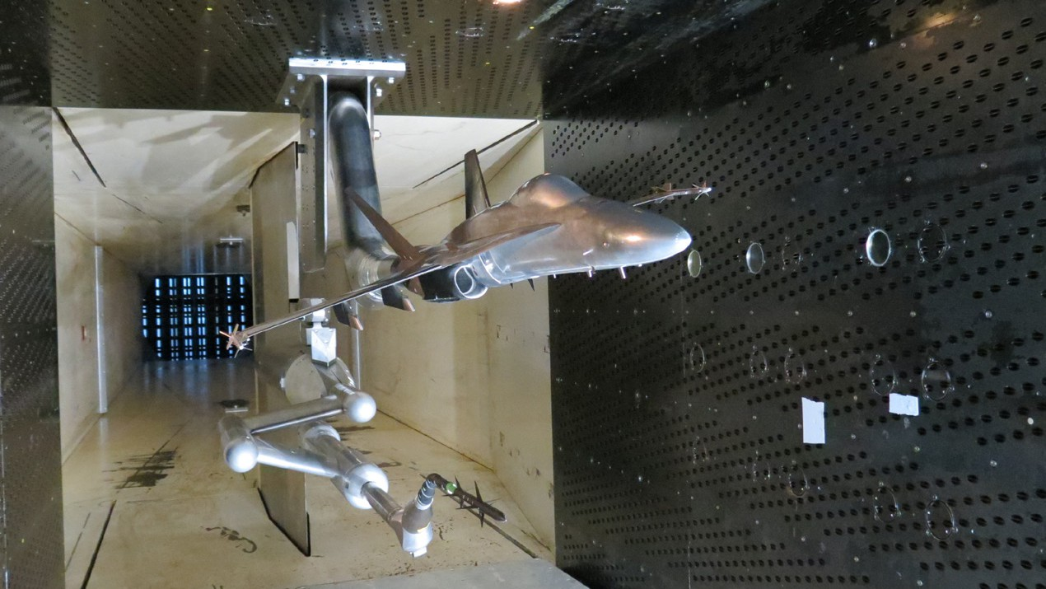
INNOVATION

1962

RCAF Tartan

James “Stocky” Edwards

The RCAF Flyers

Trisonic Wind Tunnel

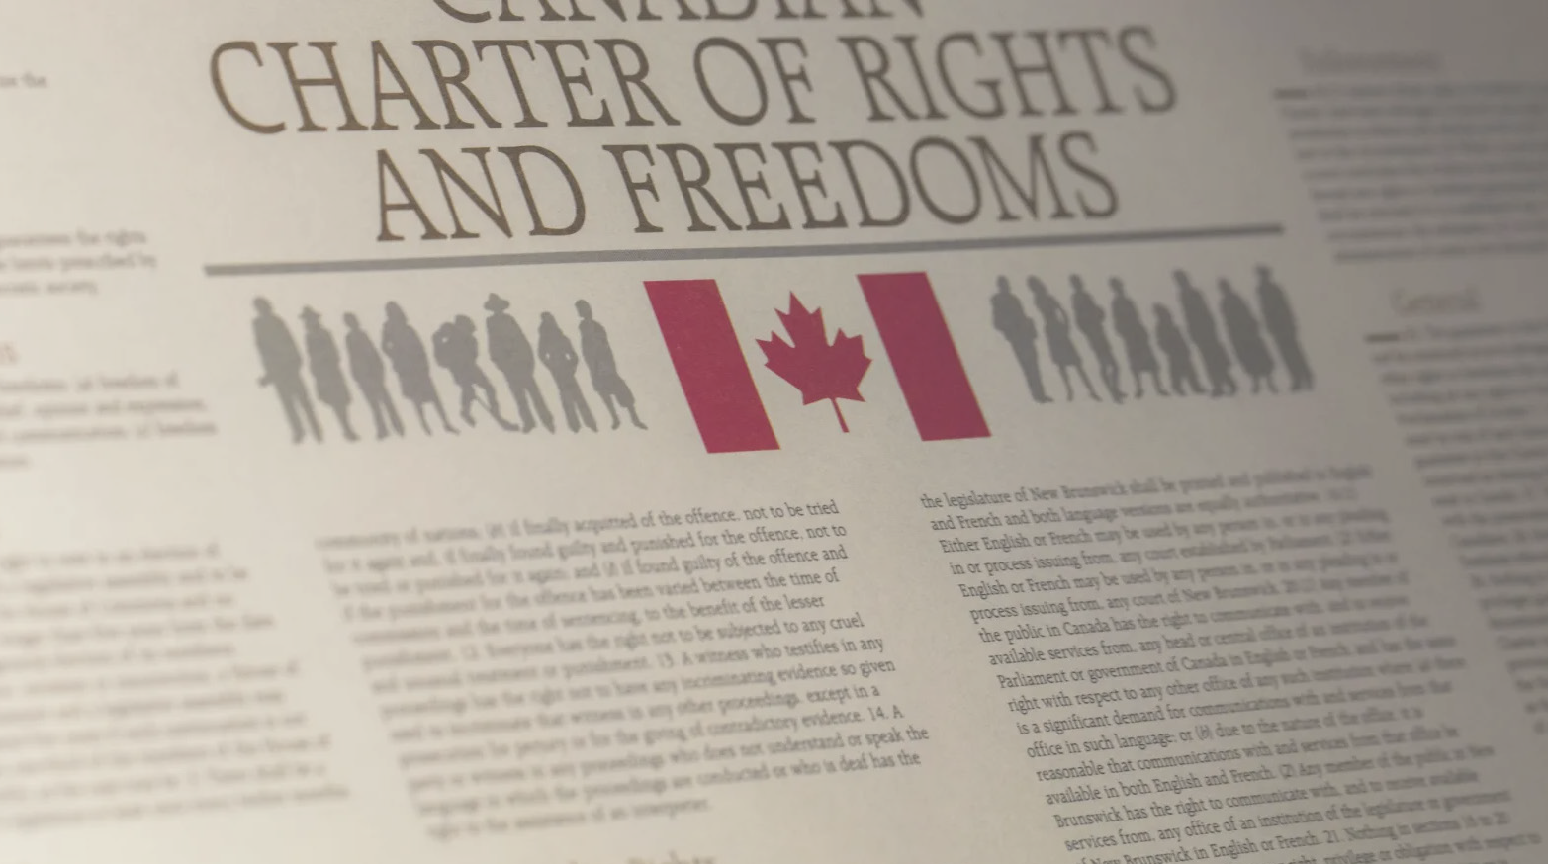
EVENT

1982
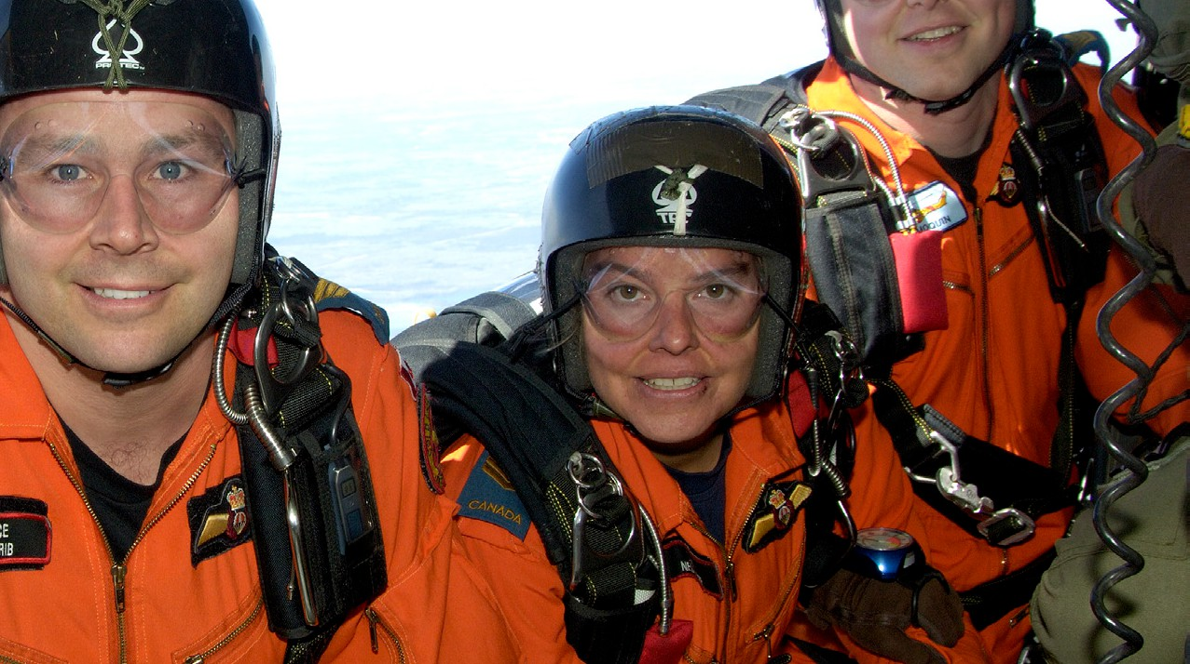
PEOPLE

1988
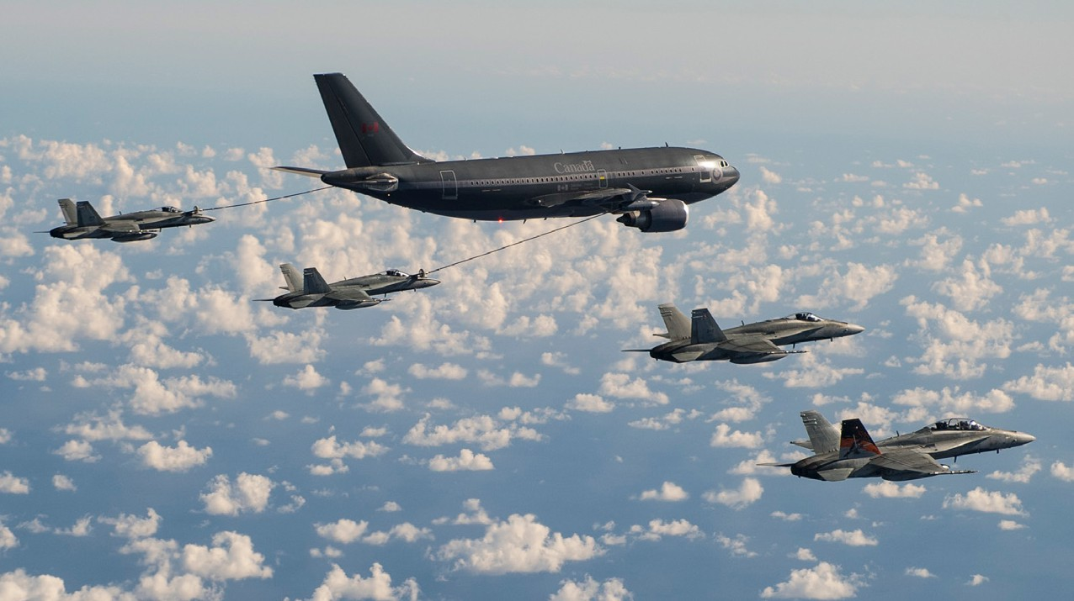
INNOVATION

1992

PEOPLE

1995

Charter of Rights and Freedoms

Tammy Negraeff

CC-150 Polaris

Chris Hadfield

EVENT
INNOVATION
PEOPLE

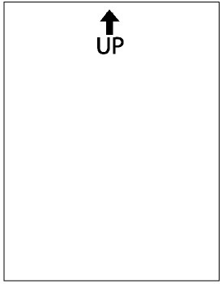
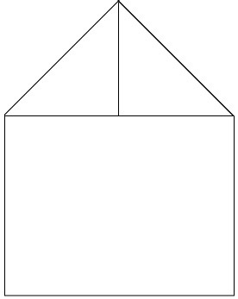
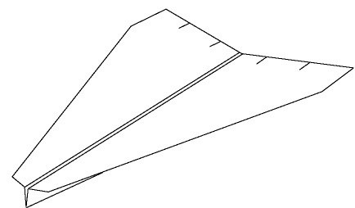
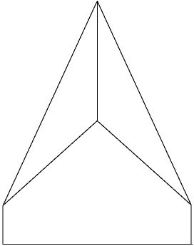
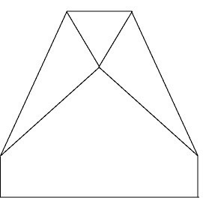
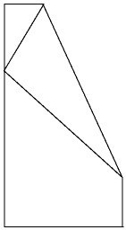
Arrow

Orient the template with the “UP” arrow at the top of the page. Then, flip the paper over onto its backside, so that you cannot see any of the fold lines.

Pull the top right corner down toward you until fold line 1 is visible and crease along the dotted line. Repeat with the top left corner.

Fold the right side over again and crease along fold line 2. Repeat with the left side.

Fold the tip down toward you and crease along fold line 3.

Now, flip the paper over. Then, fold the left side over onto the right side and crease along fold line 4 so that the outside edges of the wings line up.

Elevator

Fold the wings down along fold lines 5. Partially open the folds you just created so the wings stick out straight. Cut two slits, one inch apart, along the back edge of each wing for elevator adjustments. Add wing dihedral by tilting the wings up slightly away from the fuselage. The wings will have a slight “V” shape when viewed from the front.
14

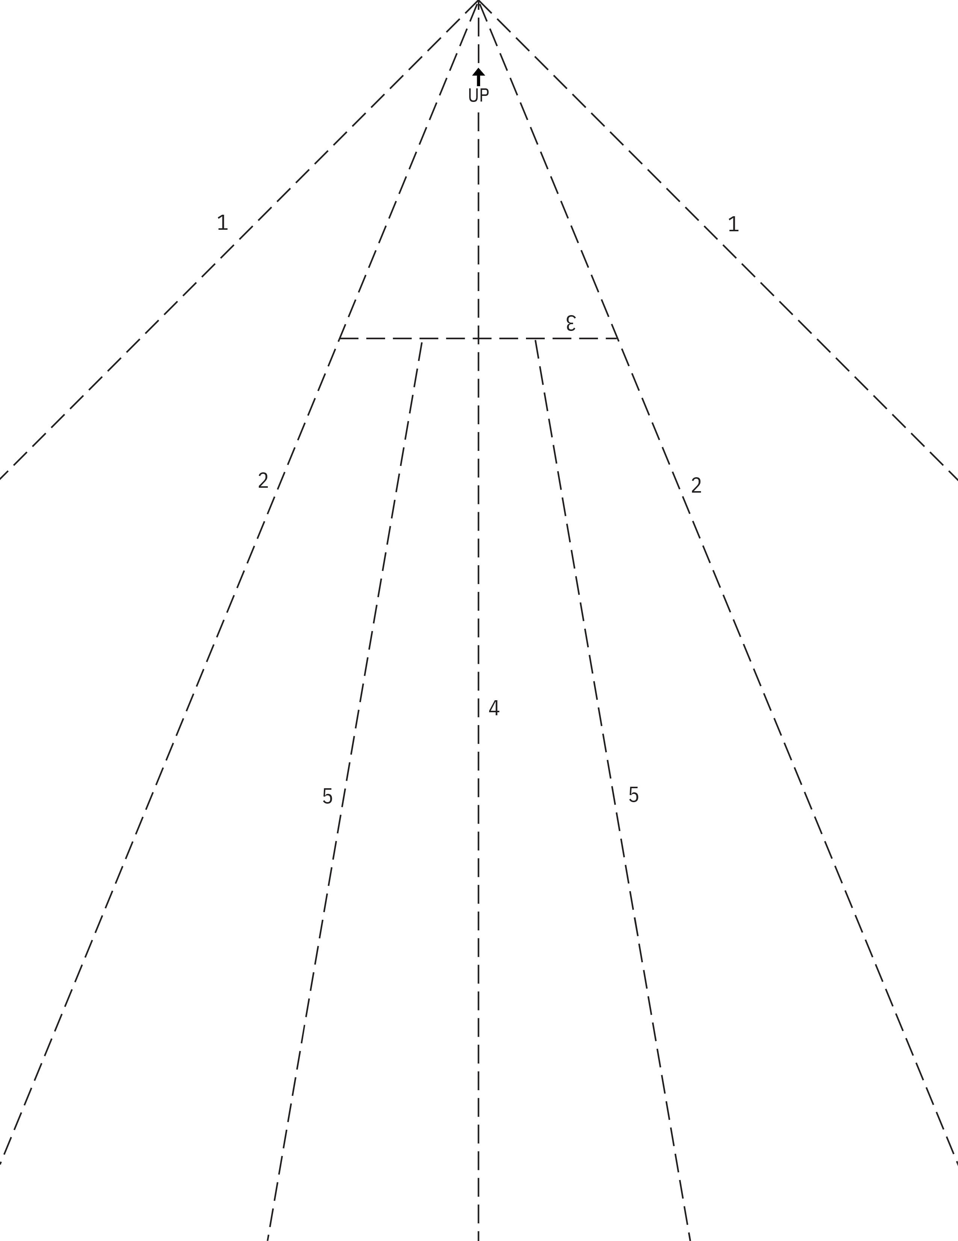

15

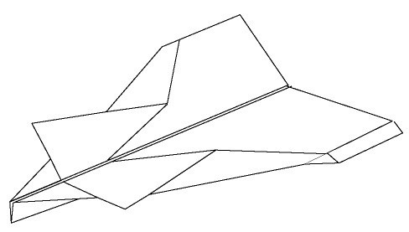
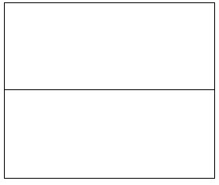
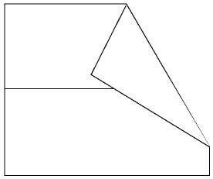
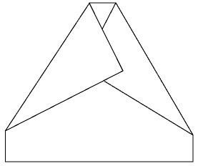
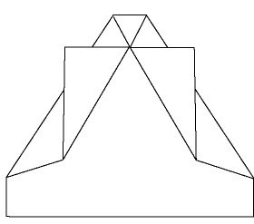
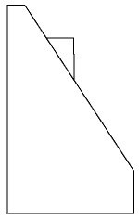
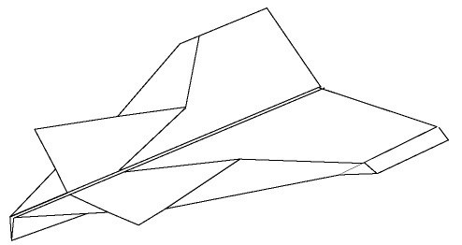
Canard

Orient the template so the “UP” arrow is at the top of the page. Then, flip the paper over so none of the fold lines are showing.

Fold the top edge of the paper down toward you until fold line 1 becomes visible. Make a crease along the dotted line.

Fold the top right corner down and toward you and make a crease along fold line 2. Be aware that you will not be able to see the fold line after making this fold.

Fold the top left corner down and toward you and make a crease along fold line 3.

Fold the corners of the flaps you just folded up along fold lines 4.

Fold the left half of the plane over onto the right half along fold line 5 so the outside edges of the wings line up.

Fold the wings down along fold lines 6 and winglets down along fold lines 7. Add wing dihedral by tilting the wings up slightly away from the fuselage. The wings will have a slight “V” shape when viewed from the front. You are ready to fly!
16

4
6
7
4
6
7
1
3
2

UP

5

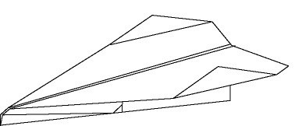
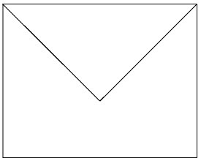
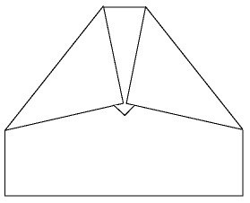
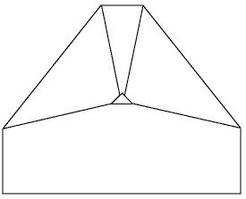
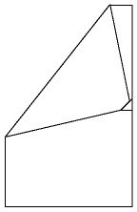
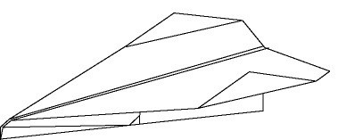
Classic Dart

Orient the template with the “UP” arrow at the top of the page.
Then, flip the paper over onto its backside, so that you cannot see any of the fold lines.

Pull the top right corner down toward you until fold line 1 is visible and crease along the dotted line. Repeat with the top left corner.

Fold the top point down toward you until fold line 2 is visible and crease along the dotted line.

Fold the top left and right corners toward you and crease along fold lines 3.

Fold the tip up and over the two diagonal folds along fold line 4 to secure them in place.

Flip the plane over and fold the right side onto the left side as shown along fold line 5, so the outside edges of the wings line up. Ensure the diagonal folds do not become untucked from the tip you folded up in the previous step.

Fold the wings down along fold lines 6 and the winglets up along fold lines 7. Add wing dihedral by tilting the wings up slightly away from the fuselage.
The wings will have a slight “V” shape when viewed from the front. Cut two slits, one inch apart, along the back edge of each wing to adjust the elevators. Begin by testing an upward elevator adjustment. You are ready to fly!
18

1
3
2
4
1
3
UP

5
6 6
7 7

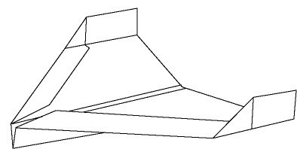
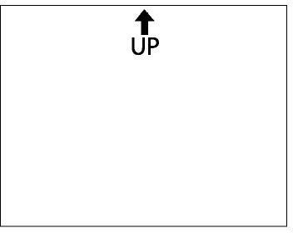
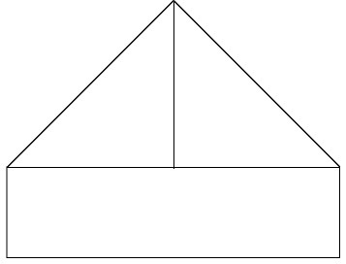
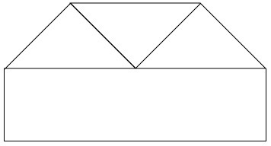
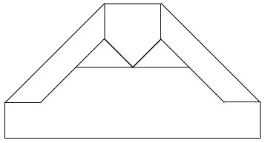
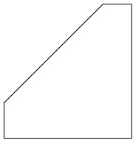
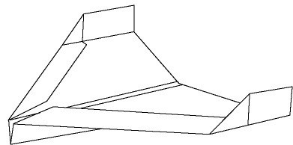
Condor

Orient the template so the “UP” arrow is at the top
of the page. Then, flip the paper over so none of the fold lines are showing.

Fold the top left corner down toward you until fold line
1 becomes visible. Crease along the dotted line and repeat with the top right corner.

Fold the nose down until fold line 2 becomes visible and crease along the dotted line.

Fold the outside wing edges in and crease along fold lines 3.

Fold the right half of the plane over the left half and crease along fold line 4 so that the outside edges of the wings line up.

Fold the wings down along fold lines 5 and the winglets up along fold lines 6. Add wing dihedral by tilting the wings up slightly away from the fuselage. The wings will have a slight “V” shape when viewed from the front. Add elevator slits along the back edge of the wings to adjust the flight if necessary.
20

UP
1
2
1

3 4 3

5 5

6 6

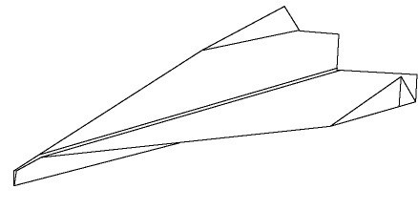
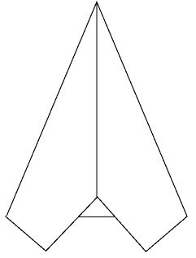
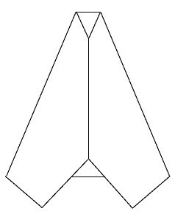
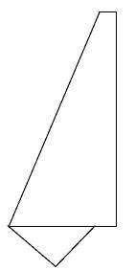
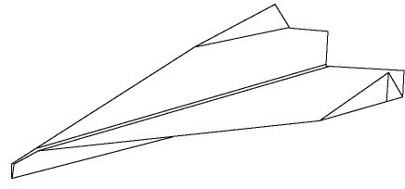
Delta
22

Orient the template so the “UP” arrow is at the top of the page. Then, flip the paper over so that none of the fold lines are showing.

Fold the top left corner down toward you until fold line 1 becomes visible. Crease along the dotted line and repeat with the top right corner.

Fold the left side over again and crease along fold line 2. Repeat with the right side.

Fold the nose down and toward you along fold line 3.

Fold the right half of the plane over the left half along fold line 4 so the outside edges of the wings line up.

Fold the wings down along fold lines 5 and the winglets up along fold lines 6. Add wing dihedral by tilting the wings up slightly away from the fuselage. The wings will have a slight “V” shape when viewed from the front.

3
UP

2 4 2
1
1

5 5

6 6

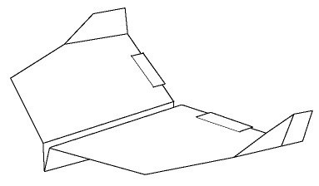
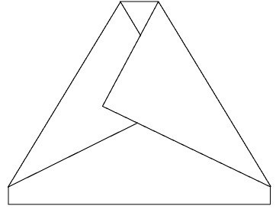
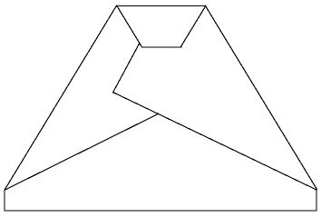
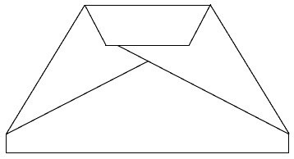
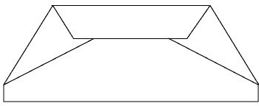
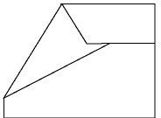
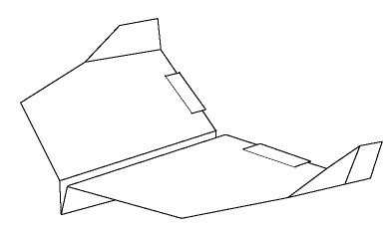
Raptor

Orient the template so the “UP” arrow is at the top
of the page. Then, flip the paper over so that none of the fold lines are showing.

Fold the top right and left corners in until fold lines 1 appear and crease along the dotted line.

Fold the nose down toward you and crease along fold line 2.

Fold the nose down toward you again and crease along fold line 3.

Fold the top edge down toward you again and crease along fold line 4.

Flip the plane over and fold the right half over the left half along fold line 5.

Flip the wings down along fold lines 6 and the winglets up along fold lines 7. Cut slits along the back wing edge for the elevator adjustment. Add wing dihedral by tilting the wings up slightly away from the fuselage. The wings will have a slight “V” shape when viewed from the front.
24

7
1
6
7
1
6
UP
4
3
2

5

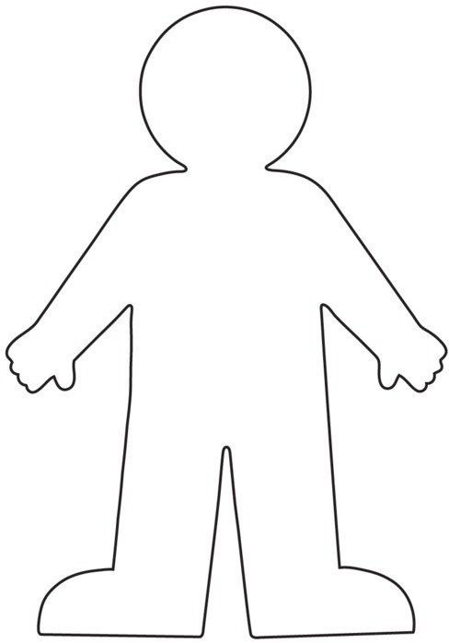

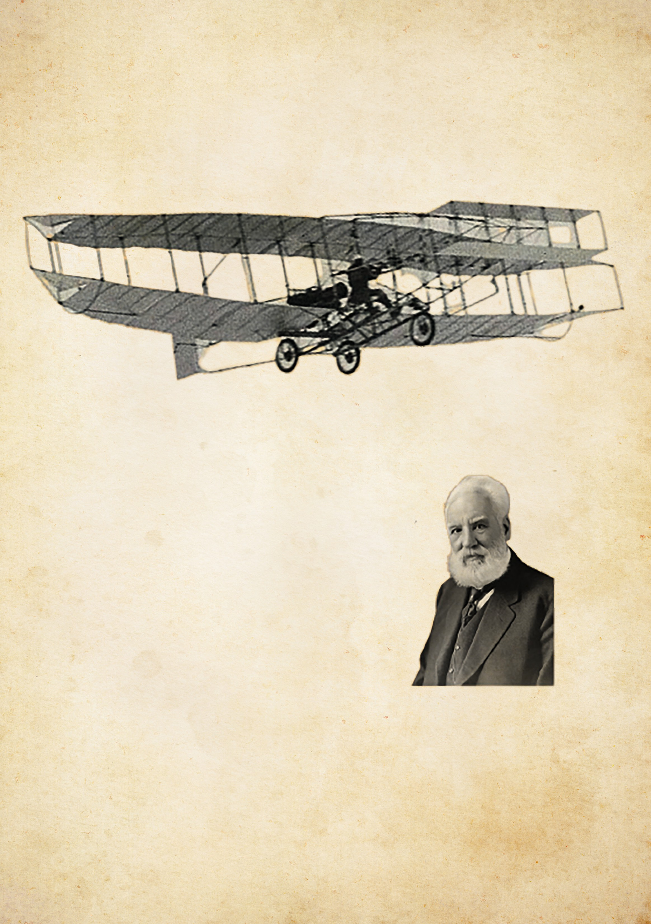
Lesson 3 Example
the

R
D
A
R
T
S
I
L
V
E

The Silver Dart was the FIRST powered flying machine in Canadian history!
The Silver Dart was made by a group of Canadians led by Alexander Graham Bell, the inventor of the telephone!
The Silver Dart’s first flight on February 23, 1909 acted as the beginning of
Canada’s aviation history. It flew over 200 times and inspired future generations of Canadian engineers, pilots, and innovators!

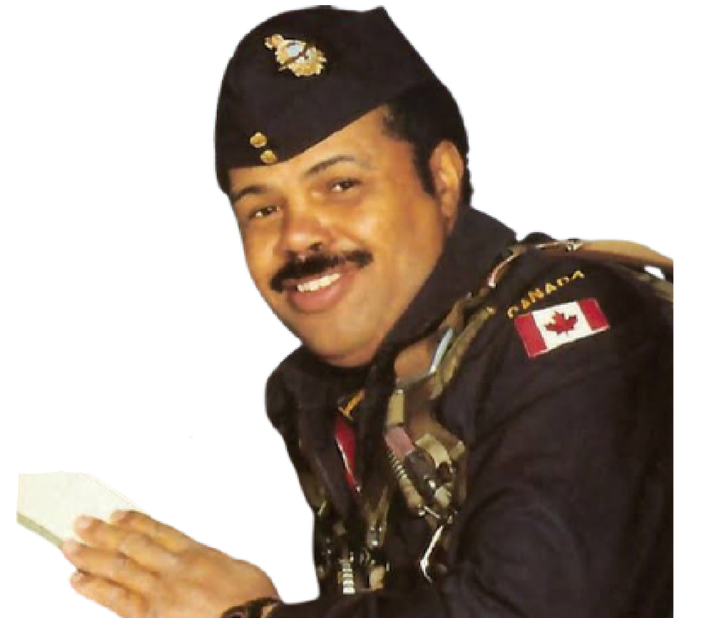
Lesson 8 Example
ALLAN

BUNDY
Allan Bundy, from Darmouth
and Nova Scotia, was Canada’s FIRST Black fighter pilot!
Bundy was one of only two Black Canadians that flew in WWII
combat missions!

Bundy flew 42 successful missions with his squadron the “Buffaloes”.
1920 - Born
Juin 1942 - Joined RCAF Octobre 1943 - First mission 2001 - Died











rcaffoundation.ca
29

